FOR IMMEDIATE RELEASE Contact: Diane Luber
January 12, 2017 Diane@KaneenPR.com
Office: (520) 885-9009; Cell: (520) 360-8068
Splendido residents donate truckload of clothing
to homeless and at-risk veterans at Tucson Stand Down
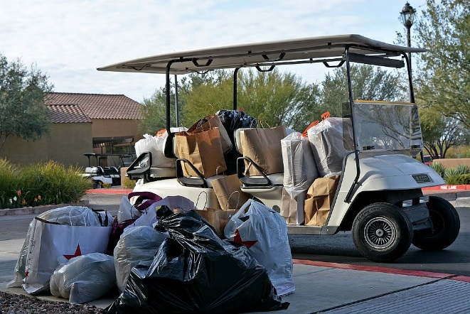
The residents of Splendido have once again exhibited their extraordinary kindness and generosity by donating clothing for homeless and at-risk veterans attending the January 13-15, 2017, Tucson Stand Down event.
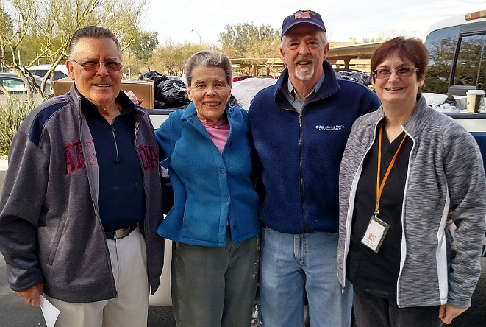
Residents donated more than 100 bags and boxes of clothing, including men’s and women’s shoes, belts, new socks and underwear, pants, shirts and much needed winter jackets and outerwear. The amount of clothing donated filled an oversize pickup truck to overflowing.
Splendido residents Curt Stowell and Julia Zahn (left); American Legion Commander Ed Davis; and Splendido employee Sue Martin.
The collection was organized by the Splendido Veterans Committee in coordination with
American Legion Oro Valley Post #132.
●●●
Splendido is an all-inclusive Life Plan Community for adults 55 and better with Terrace and Villa Homes, a fitness center and pools, salon and spa, restaurants, 18-hole putting course and movie theater; and an on-site health center that offers assisted living, memory support, Medicare-certified skilled nursing, and rehabilitation if ever needed.
13500 N. Rancho Vistoso Blvd., Tucson AZ 85755
(520) 878.2612
info@splendidotucson.com splendidotucson.com
facebook.com/splendidotucson

